

Faculty of Information Technology

PROJECT REPORT ON

“HEART DISEASE ANALYSIS

USING TABLEAU”

Submitted in Partial Fulfillment of the Requirements for the Award of the Internship Completion Certificate

Academic Session
2025 – 2026

Submitted By : Submitted To:
Devang Agrawal (Team Leader) NASSCOM Data Analytics Internship
Vishwraj Singh Rajawat (Team Member) Project Domain: Data Analytics
Rashmi Kumari Mahawar (Team Member)
Lakshitha O Gour (Team Member)

CERTIFICATE
This is to certify that the project entitled "Heart Disease Analysis Using Tableau" has been carried out by the following students of The ICFAI University, Jaipur as a part of the academic requirements for the award of the degree.

Project Team
- Devang Agrawal (Team Leader)
- Vishwraj Singh Rajawat (Member)
- Rashmi Kumari Mahawar (Member)
- Lakshitha O Gour (Member)
The project has been completed under my guidance during the academic session 2025–2026.
This report is an original work carried out by the above-mentioned students. To the best of my knowledge, the work presented in this project has not been submitted previously, either in full or in part, for the award of any degree, diploma, or other academic qualification at this or any other university or institution.
The project demonstrates the practical application of MySQL Workbench and Tableau Public for analyzing heart disease data through interactive dashboards, storytelling, performance testing, publishing, and web integration. The students have completed the project sincerely and successfully, fulfilling the objectives and requirements of the study.
I wish them success in their future academic and professional endeavors.

Faculty Guide
Name: _______________________________
Designation: _________________________
Signature: ___________________________

Head of Department
Name: _______________________________
Department: _________________________
Signature & Seal: ___________________________
Date: _______________________________

ACKNOWLEDGEMENT
The successful completion of this project would not have been possible without the guidance, support, and encouragement of many individuals and organizations. We would like to express our sincere gratitude to everyone who contributed directly or indirectly to the completion of this project.
First and foremost, we would like to thank NASSCOM for providing us with the opportunity to participate in the internship program. During the internship, we were assigned the project "Heart Disease Analysis Using Tableau" in the field of Data Analytics. This project provided us with valuable practical exposure to real-world data analysis, database management, and business intelligence tools.
We express our heartfelt gratitude to The ICFAI University, Jaipur for encouraging us to apply the knowledge gained during our academic program in a practical environment.
We are sincerely thankful to our Faculty Guide for their valuable guidance, continuous support, and constructive suggestions throughout the project. Their encouragement helped us complete every stage of the project successfully.
We also acknowledge SkillWallet for providing the Heart Disease dataset, which served as the primary source of data for our analysis. The dataset enabled us to perform data cleaning, database implementation using MySQL Workbench, dashboard development in Tableau Public, storytelling, performance testing, publishing, and web integration.
We would also like to thank the teams behind MySQL Workbench, Tableau Public, GitHub, and OBS Studio for providing the tools that made the successful completion of this project possible.
Finally, we express our sincere gratitude to our parents, family members, friends, and teammates for their continuous motivation, cooperation, and encouragement throughout this internship and project.

Project Team
- Devang Agrawal (Team Leader)
- Vishwraj Singh Rajawat (Member)
- Rashmi Kumari Mahawar (Member)
- Lakshitha O Gour (Member)

ABSTRACT
Heart disease is one of the leading causes of death worldwide and continues to be a major public health concern. Various factors such as age, gender, obesity, smoking, alcohol consumption, diabetes, lack of physical activity, and poor general health significantly increase the risk of developing cardiovascular diseases. Analyzing these factors through data visualization helps healthcare professionals and policymakers understand disease patterns and make informed decisions.
This project, "Heart Disease Analysis Using Tableau," was assigned during the NASSCOM Data Analytics Internship to provide practical exposure to Business Intelligence and data visualization techniques. The primary objective of the project was to analyze healthcare data and present meaningful insights using interactive dashboards developed in Tableau Public.
The heart disease dataset was obtained from the SkillWallet Dashboard. Before analysis, the dataset was carefully examined and cleaned by removing duplicate and redundant records to improve data quality. The cleaned dataset was then imported into MySQL Workbench, where SQL operations were performed to organize and validate the data. After successful database implementation, MySQL was connected with Tableau Public to create interactive dashboards.
Three dashboards were developed based on different real-world scenarios. The first dashboard focuses on helping doctors identify lifestyle factors contributing to heart disease. The second dashboard supports government authorities in understanding health trends for policy planning. The third dashboard enables individuals to monitor their health risks through simplified visual analysis.
In addition to the dashboards, a Tableau Story was created to present the complete analysis in a logical sequence. Performance testing was conducted to ensure smooth dashboard functionality, and the final dashboards were published on Tableau Public and integrated into a web page for easy accessibility.
The project enhanced practical knowledge of MySQL, SQL, Tableau Public, data visualization, dashboard development, storytelling, and web integration. It also demonstrated how Business Intelligence tools can transform raw healthcare data into meaningful visual insights that support better healthcare decision-making

TABLE OF CONTENTS
S. No. | Contents | Page No.

1 | Cover Page | 1

2 | Certificate | 2

3 | Acknowledgement | 3

4 | Abstract | 4

5 | Table of Contents | 5

6 | Introduction | 6

7 | Problem Understanding | 7

8 | Business Requirements | 8

9 | Literature Survey | 9

10 | Objectives of the Project | 10

11 | Scope of the Project | 11

12 | Dataset Collection & Description | 12

13 | Data Cleaning and Preprocessing | 13

14 | MySQL Database Implementation | 14

15 | SQL Queries Used | 15

16 | Connecting MySQL with Tableau Public | 16

17 | Project Methodology | 17

18 | Dashboard Development Overview | 18

19 | Dashboard 1 – Doctor's Perspective | 19-20

20 | Dashboard 2 – Government Perspective | 21-22

21 | Dashboard 3 – Individual/User Perspective | 23-24

22 | Tableau Story | 25

23 | Performance Testing | 26-27

24 | Publishing on Tableau Public | 28

25 | Web Integration | 29-30

26 | Results and Findings | 31

27 | Conclusion | 32

28 | Future Scope | 33

29 | References | 34

INTRODUCTION
Heart disease is one of the most common and serious health problems across the world. According to various health reports, cardiovascular diseases are responsible for a significant number of deaths every year. Several lifestyle and medical factors such as age, obesity, smoking, alcohol consumption, diabetes, lack of physical activity, high Body Mass Index (BMI), and poor general health increase the risk of developing heart disease. Therefore, identifying these risk factors at an early stage is essential for improving healthcare decisions and promoting preventive measures.
With the rapid growth of digital healthcare systems, hospitals and medical organizations generate a large amount of patient data every day. Although this data contains valuable information, it is difficult to analyze using traditional reporting methods. Large datasets often make it challenging to identify patterns, trends, and relationships between different health factors. Business Intelligence (BI) tools help overcome this challenge by converting raw data into meaningful visual information that supports better decision-making.
This project, "Heart Disease Analysis Using Tableau," was assigned during the NASSCOM Data Analytics Internship to provide practical exposure to data analysis and visualization techniques. The project focuses on analyzing heart disease data using MySQL Workbench and Tableau Public. The dataset was downloaded from the SkillWallet Dashboard, cleaned by removing duplicate and redundant records, stored in MySQL, and then connected to Tableau for visualization.
The project includes three interactive dashboards developed according to different real-world scenarios. The first dashboard helps doctors identify patients who are at higher risk of heart disease. The second dashboard supports government authorities in understanding disease trends and planning public health initiatives. The third dashboard enables individuals to compare their health indicators with common risk factors and understand the importance of maintaining a healthy lifestyle.
A Tableau Story was also created to present the analysis in a logical sequence, making the findings easier to understand. Finally, the dashboards were tested, published on Tableau Public, and integrated into a web page to improve accessibility.
This project demonstrates how Business Intelligence tools can transform healthcare data into interactive dashboards that provide meaningful insights and support informed decision-making in the healthcare sector.

PROBLEM UNDERSTANDING
Heart disease is one of the leading causes of death worldwide and has become a major public health concern. The increasing number of heart disease cases is mainly associated with unhealthy lifestyle habits such as smoking, alcohol consumption, obesity, lack of physical activity, diabetes, and poor general health. Since multiple factors contribute to heart disease, healthcare professionals require efficient methods to analyze patient data and identify individuals who are at higher risk.
Healthcare organizations collect a large amount of patient information every day, including demographic details, medical history, lifestyle habits, and clinical records. Although this data contains valuable information, it is difficult to analyze manually because of its large volume and complexity. Traditional reports and spreadsheets often fail to provide clear insights into disease patterns and relationships among different health factors.
The main problem addressed in this project is the lack of an interactive system that can convert raw healthcare data into meaningful visual information. Without proper visualization, identifying trends, comparing patient groups, and understanding the impact of various risk factors becomes time-consuming and less effective.
To overcome this problem, the project uses MySQL Workbench for database management and Tableau Public for data visualization. The heart disease dataset collected from the SkillWallet Dashboard was cleaned, stored in a structured database, and analyzed using interactive dashboards. These dashboards help users understand how different factors such as age, gender, BMI, smoking, alcohol consumption, diabetes, stroke, race, and physical activity influence the occurrence of heart disease.
The project has been designed to meet the requirements of three different users. Healthcare professionals can identify high-risk patients for early intervention, government authorities can analyze disease trends to support public health planning, and individuals can better understand their own health risks by comparing lifestyle factors with heart disease indicators.
By transforming healthcare data into interactive dashboards and stories, this project simplifies data analysis, improves understanding of disease patterns, and supports better healthcare decision-making.

BUSINESS REQUIREMENTS
The success of any data analytics project depends on clearly identifying its business requirements. These requirements define the expected functionality of the system and ensure that the final solution meets the needs of its users. In this project, the primary objective was to analyze heart disease data and present meaningful insights through interactive dashboards using Tableau Public.
The project was assigned during the NASSCOM Data Analytics Internship, where the objective was to apply Business Intelligence concepts to solve a real-world healthcare problem. The system was designed to help doctors, government organizations, and individuals understand the factors influencing heart disease and support informed decision-making.
The following business requirements were identified for the successful completion of the project.

Functional Requirements
The project should be capable of performing the following functions:
- Download the Heart Disease dataset from the SkillWallet Dashboard.
- Remove duplicate and redundant records to improve data quality.
- Store the cleaned dataset in MySQL Workbench.
- Execute SQL queries to validate and manage the data.
- Connect the MySQL database with Tableau Public.
- Create interactive dashboards for data visualization.
- Develop a Tableau Story to present the analysis in a logical sequence.
- Apply interactive filters for better user experience.
- Perform performance testing to ensure dashboard efficiency.
- Publish the completed dashboards on Tableau Public.
- Integrate the published dashboard into a web page for easy access.

Non-Functional Requirements
In addition to the functional requirements, the project should satisfy the following quality requirements:
- The dashboards should be easy to understand and user-friendly.
- Data should be displayed accurately without inconsistencies.
- Dashboard response time should be fast.
- The system should support interactive filtering and visualization.
- Database operations should be reliable and efficient.
- The published dashboard should be accessible through a web browser.
- The project should provide meaningful insights for different types of users.

LITERATURE SURVEY
A literature survey is an important part of any project as it provides an understanding of previous work related to the selected topic. For this project, various research articles, healthcare reports, online resources, and documentation related to heart disease, data analytics, Business Intelligence, MySQL, and Tableau were studied to understand existing methods of healthcare data analysis.
Heart disease has remained one of the leading causes of mortality across the world. Many researchers have highlighted that factors such as age, gender, obesity, diabetes, smoking, alcohol consumption, physical inactivity, and poor general health significantly influence the risk of cardiovascular diseases. Understanding these factors through data analysis helps healthcare professionals make informed decisions and supports early diagnosis.
Several studies have also emphasized the importance of Business Intelligence (BI) tools in healthcare. BI tools help transform large volumes of healthcare data into meaningful visual information, making it easier to identify trends, compare patient groups, and monitor disease patterns. Interactive dashboards allow users to analyze healthcare information more efficiently than traditional reports or spreadsheets.
The documentation of Tableau Public was reviewed to understand its visualization features, dashboard creation process, filters, and storytelling capabilities. Tableau is widely used because it supports interactive charts, multiple visualization types, and easy publishing of dashboards on the web.
The official documentation of MySQL Workbench was also referred to for understanding database creation, data import, SQL query execution, and database management. MySQL provides a structured environment for storing and managing healthcare data before it is connected to Tableau for visualization.
The knowledge gained from these resources helped in designing an effective workflow for this project, including dataset collection, data cleaning, database implementation, dashboard development, story creation, performance testing, publishing, and web integration. The literature survey provided a strong foundation for developing a practical Business Intelligence solution for heart disease analysis.

OBJECTIVES OF THE PROJECT
The primary objective of this project is to analyze heart disease data using MySQL Workbench and Tableau Public and present the findings through interactive dashboards. The project focuses on transforming raw healthcare data into meaningful visual information that can help users understand the major factors associated with heart disease.
Another important objective is to gain practical knowledge of Data Analytics by applying the concepts learned during the NASSCOM Data Analytics Internship. The project provides hands-on experience in data collection, data cleaning, database management, SQL operations, dashboard development, storytelling, performance testing, publishing, and web integration.
The project also aims to identify the relationship between different health indicators such as age, gender, Body Mass Index (BMI), smoking habits, alcohol consumption, diabetes, stroke, race, general health, and physical activity. Understanding these relationships helps in identifying the factors that increase the risk of heart disease.
A further objective is to develop three scenario-based dashboards that address the requirements of different users. The first dashboard supports doctors in identifying high-risk patients. The second dashboard helps government authorities analyze healthcare trends for policy planning. The third dashboard enables individuals to understand their health condition by comparing different health indicators.
The project also focuses on improving technical skills by integrating MySQL Workbench with Tableau Public. This integration demonstrates how structured databases can be connected with Business Intelligence tools to perform efficient data analysis and visualization.
Finally, the project aims to publish the completed dashboards on Tableau Public and integrate them into a web page so that users can access the dashboards online. This demonstrates the complete implementation of a Business Intelligence solution from data collection to web deployment.

The main objectives of the project are:
- To analyze heart disease data using Tableau Public.
- To clean and prepare the dataset for analysis.
- To store the dataset in MySQL Workbench.
- To perform SQL operations for data management.
- To create interactive dashboards and stories.
- To identify major heart disease risk factors.
- To publish dashboards on Tableau Public.
- To integrate the dashboard into a web page.
- To gain practical experience in Data Analytics and Business Intelligence.

SCOPE OF THE PROJECT
The scope of this project is to analyze heart disease data using Business Intelligence tools and present meaningful insights through interactive dashboards. The project demonstrates how healthcare data can be transformed into visual reports that support better understanding and decision-making.
The project begins with collecting the Heart Disease dataset from the SkillWallet Dashboard. After downloading the dataset, data preprocessing activities such as removing duplicate records, eliminating redundant information, and validating the dataset were performed to improve data quality. The cleaned dataset was then stored in MySQL Workbench, where SQL operations were used to organize and manage the data efficiently.
The project also includes connecting the MySQL database with Tableau Public to develop interactive dashboards. Different visualizations were created to analyze important factors such as age, gender, Body Mass Index (BMI), race, smoking habits, alcohol consumption, diabetes, stroke, general health, and physical activity. These dashboards provide a better understanding of the relationship between various health indicators and heart disease.
Another important scope of the project is the development of three scenario-based dashboards. Each dashboard has been designed to meet the requirements of different users, including doctors, government health departments, and individual patients. In addition, a Tableau Story was created to present the dashboards in a logical sequence and improve data storytelling.
The project also covers performance testing, publishing the dashboards on Tableau Public, and integrating the published dashboards into a web page. These activities demonstrate the complete workflow of a Business Intelligence project, from data collection to final deployment.
Although the project focuses only on heart disease analysis, the same methodology can be applied to other healthcare datasets for disease prediction, hospital management, and public health analysis.

DATASET COLLECTION&DESCRIPTION
The dataset used in this project is a Heart Disease Dataset provided through the SkillWallet Dashboard during the NASSCOM Data Analytics Internship. The dataset contains healthcare-related information collected from patients and includes various demographic, lifestyle, and medical attributes that are commonly associated with heart disease.
The dataset was selected because it provides sufficient information to analyze the relationship between different health indicators and the occurrence of heart disease. It allows users to identify patterns, compare different patient groups, and understand the major risk factors affecting cardiovascular health.
The dataset consists of multiple records, where each record represents the health information of an individual patient. Every record contains several attributes that describe the patient's physical condition, lifestyle habits, and medical history.
Some of the important attributes available in the dataset include Heart Disease, Age Category, Gender, Race, Body Mass Index (BMI), Smoking Status, Alcohol Drinking, Physical Activity, Diabetes, Stroke, General Health, Mental Health, Physical Health, and Sleep Time. These attributes were used to create different visualizations and interactive dashboards in Tableau Public.
The collected dataset was stored in CSV (Comma Separated Values) format, making it easy to import into MySQL Workbench and connect with Tableau Public. Before visualization, the dataset was verified to ensure that all columns contained appropriate values and were suitable for analysis.
The availability of demographic, behavioural, and medical attributes made this dataset highly suitable for developing scenario-based dashboards. It helped in identifying the relationship between various lifestyle factors and heart disease, enabling the creation of meaningful visual insights for doctors, government organizations, and individual users.
Overall, the dataset served as the foundation of the entire project and played an important role in achieving the objectives of healthcare data analysis using Business Intelligence tools.

DATA CLEANING AND PREPROCESSING
Data cleaning and preprocessing are essential steps in any data analytics project because the quality of the final analysis depends on the quality of the dataset. Raw datasets often contain duplicate records, redundant information, missing values, and inconsistent data, which may affect the accuracy of the visualizations and analytical results.
After downloading the Heart Disease dataset from the SkillWallet Dashboard, the dataset was carefully examined before importing it into MySQL Workbench. Each attribute was reviewed to ensure that the data was complete, consistent, and suitable for analysis.
The first preprocessing activity involved identifying and removing duplicate records. Duplicate entries can lead to incorrect analytical results by counting the same information multiple times. All duplicate records found in the dataset were removed to maintain data accuracy.
The dataset was also checked for redundant information. Repeated or unnecessary data increases storage requirements and affects query performance. Such redundant information was eliminated to improve the efficiency of the database and Tableau dashboards.
After cleaning the dataset, the data types and column values were verified to ensure consistency. The cleaned dataset was then saved in CSV format, which was later imported into MySQL Workbench for database implementation.
The preprocessing stage significantly improved the quality of the dataset by ensuring that only accurate and relevant records were used for analysis. This process also enhanced the performance of SQL queries and Tableau dashboards, resulting in faster loading times and more reliable visualizations.
The cleaned dataset provided a strong foundation for creating interactive dashboards and helped generate meaningful insights into the factors contributing to heart disease.

MYSQL DATABASE IMPLEMENTATION
After completing the data cleaning and preprocessing stage, the cleaned Heart Disease dataset was imported into MySQL Workbench for database management. MySQL Workbench was selected because it provides a reliable environment for storing, organizing, and managing structured data. It also supports SQL operations and can be easily connected with Tableau Public for data visualization.
The first step was to create a new database named heart_new. After creating the database, a table was created to store all the attributes available in the Heart Disease dataset. The cleaned CSV file was then imported into the table using the Table Data Import Wizard available in MySQL Workbench.
Once the import process was completed, the data was verified by checking the total number of records, column names, and data types. This verification ensured that the dataset had been imported successfully without any data loss or inconsistencies.
MySQL Workbench was used because it offers several advantages, such as efficient data storage, faster query execution, improved data security, and better database management. Storing the dataset in a database also improves the performance of Tableau dashboards, especially when working with large datasets.
The database implementation stage played an important role in this project because it provided a structured foundation for performing SQL operations before connecting the database with Tableau Public. It also ensured that the data remained organized, consistent, and ready for visualization.
Overall, MySQL Workbench served as an effective database management system that simplified data handling and supported the successful implementation of the Heart Disease Analysis project.

SQL QUERIES USED
Structured Query Language (SQL) was used to verify, organize, and analyze the Heart Disease dataset stored in MySQL Workbench. SQL queries helped ensure that the imported data was accurate before connecting it with Tableau Public. These queries were also useful for checking the number of records, grouping patient information, and validating different health-related attributes.
Some of the important SQL queries used during the project are shown below.

Create Database
CREATE DATABASE heart_dis;
- Select Database
USE heart_dis;
- Display Complete Dataset
SELECT * FROM heart_new;

Count Total Records
SELECT COUNT(*)AS TOTAL_ROWS FROM heart_new;

Count Total Column
SELECT COUNT(*)AS TOTAL_COLUMNS FROM INFORMATION_SCHEMA.COLUMNS WHERE TABLE_SCHEMA=’heart_dis’ AND TABLE_NAME=’HEART_NEW;
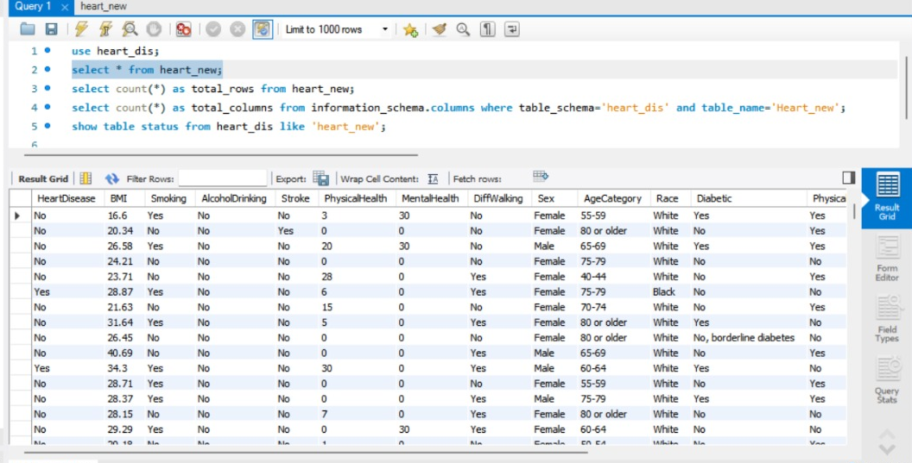

PROJECT METHODOLOGY
The methodology adopted for this project follows a systematic approach to ensure accurate data analysis and meaningful visualization. Each phase of the project was completed in sequence, beginning with data collection and ending with publishing the dashboards on Tableau Public.
The first stage involved collecting the Heart Disease dataset from the SkillWallet Dashboard provided during the NASSCOM Data Analytics Internship. After downloading the dataset in CSV format, the data was examined to identify duplicate records, redundant information, and inconsistencies. Data cleaning and preprocessing were performed to improve data quality before database implementation.
The cleaned dataset was then imported into MySQL Workbench, where SQL operations were used to verify, organize, and manage the data. After successful database implementation, the dataset was connected to Tableau Desktop for dashboard development. Interactive charts, filters, and visualizations were created to analyze different factors influencing heart disease.
Three dashboards were developed based on different user scenarios, followed by the creation of a Tableau Story to present the complete analysis in a logical sequence. Performance testing was conducted to ensure that all dashboards and filters functioned correctly. Finally, the project was published on Tableau Public and integrated into a web page for online access.

Project Workflow

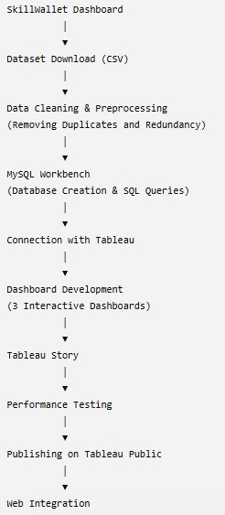
This methodology ensured a structured workflow and enabled the successful completion of the Heart Disease Analysis project using Business Intelligence tools.

DASHBOARD DEVELOPMENT OVERVIEW
After successfully connecting the Heart Disease dataset with Tableau, the next stage of the project involved developing interactive dashboards to visualize the data effectively. The primary objective of dashboard development was to transform complex healthcare data into simple, meaningful, and interactive visualizations that help users understand the factors influencing heart disease.
The dashboards were developed using Tableau Public, which provides various visualization options such as bar charts, line charts, scatter plots, heat maps, and interactive filters. During the dashboard design process, emphasis was placed on creating a clean layout, consistent formatting, appropriate color combinations, and easy navigation so that users could understand the information without difficulty.
The project consists of three dashboards, each designed for a specific user perspective. The first dashboard focuses on helping doctors identify patients at higher risk of heart disease based on demographic and lifestyle factors. The second dashboard supports government authorities in understanding healthcare trends and disease distribution among different population groups. The third dashboard is designed for individuals to understand the relationship between diabetes, stroke, and heart disease and to encourage healthier lifestyle choices.
Interactive filters were added to improve the user experience by allowing users to explore the data according to their requirements. Each dashboard displays multiple visualizations that compare different healthcare parameters and provide meaningful insights into heart disease risk factors.
The dashboard development stage played a significant role in converting raw healthcare data into informative visual reports. These dashboards form the core of the project and serve as the foundation for the Tableau Story and the final analysis presented in this report.

DASHBOARD 1 – DOCTOR'S PERSPECTIVE
The first dashboard was developed to assist doctors and healthcare professionals in identifying patients who are more likely to develop heart disease. It focuses on demographic characteristics, lifestyle habits, and physical health indicators that influence cardiovascular health. The dashboard provides a visual representation of important healthcare factors, enabling doctors to quickly identify high-risk groups and support preventive healthcare decisions.
The dashboard contains five interactive visualizations, each highlighting a different aspect of heart disease analysis:

1. Age Wise Heart Disease
This visualization shows the distribution of heart disease across different age groups. It helps identify the age categories with the highest number of heart disease cases, allowing healthcare professionals to focus on vulnerable populations.

2. Gender Wise Heart Disease
This chart compares the occurrence of heart disease between male and female patients. It provides a clear understanding of gender-based differences in heart disease prevalence.

3. Impact of Smoking and Alcohol Drinking on Heart Disease
This visualization demonstrates how smoking and alcohol consumption influence the occurrence of heart disease. It highlights the importance of healthy lifestyle choices and helps doctors educate patients about these risk factors.

4. Physical Activity vs Heart Disease
This chart analyzes the relationship between physical activity and heart disease. It shows how regular physical exercise can contribute to reducing the risk of cardiovascular diseases.

5. Age and BMI vs Heart Disease
This visualization combines Age Category and Body Mass Index (BMI) to study their combined impact on heart disease. It assists doctors in identifying patients who may require additional medical attention due to age and obesity-related risk factors.
Overall, Dashboard 1 provides a comprehensive overview of the major lifestyle and demographic factors associated with heart disease. It enables healthcare professionals to make informed clinical decisions and supports early identification of patients who may benefit from preventive healthcare interventions.

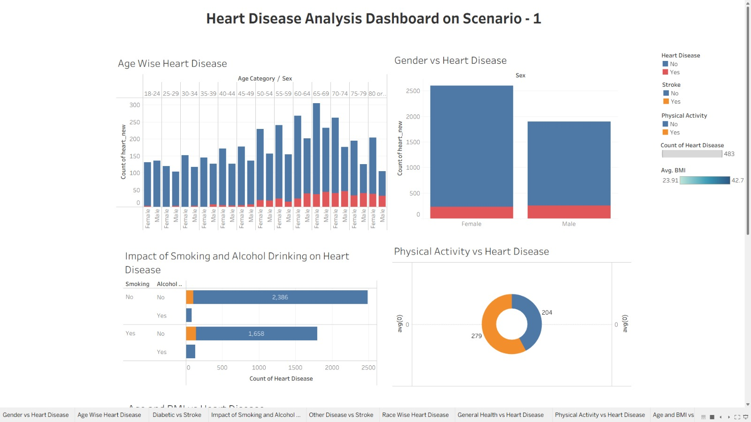
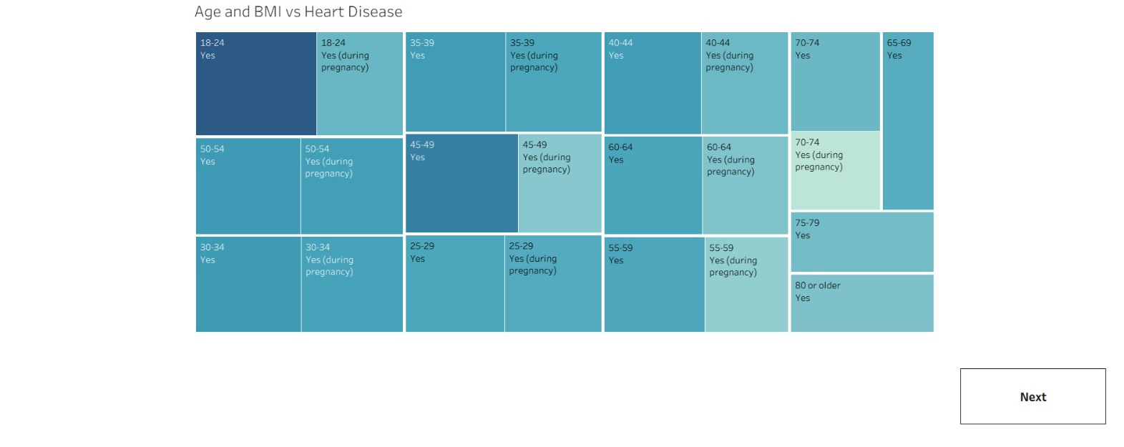

DASHBOARD 2 – GOVERNMENT PERSPECTIVE
he second dashboard was designed from the perspective of government authorities and public health organizations. Its main objective is to analyze heart disease distribution among different population groups and identify important health trends. The insights generated from this dashboard support healthcare planning, awareness campaigns, and policy-making for disease prevention.
This dashboard contains five interactive visualizations focusing on different healthcare factors related to heart disease.

1. Race Wise Heart Disease
This visualization presents the distribution of heart disease among different racial groups. It helps government agencies identify high-risk communities and plan targeted healthcare programs.

2. General Health vs Heart Disease
This chart compares general health status with heart disease occurrence. It shows that individuals reporting poor or fair health are more likely to suffer from heart disease.

3. Physical Activity vs Heart Disease
This visualization analyzes the relationship between physical activity and heart disease. It demonstrates that regular physical activity is associated with a lower risk of heart disease and supports health promotion initiatives.

4. Impact of Smoking and Alcohol Drinking on Heart Disease
This chart highlights the effect of smoking and alcohol consumption on heart disease. It supports the development of public awareness campaigns aimed at encouraging healthier lifestyle choices.

5. Age Wise Heart Disease
This visualization illustrates the distribution of heart disease across different age groups, helping identify age categories that require greater healthcare attention.
Overall, Dashboard 2 provides valuable insights into heart disease trends across different population groups. It supports healthcare planning, resource allocation, and the development of effective public health policies.
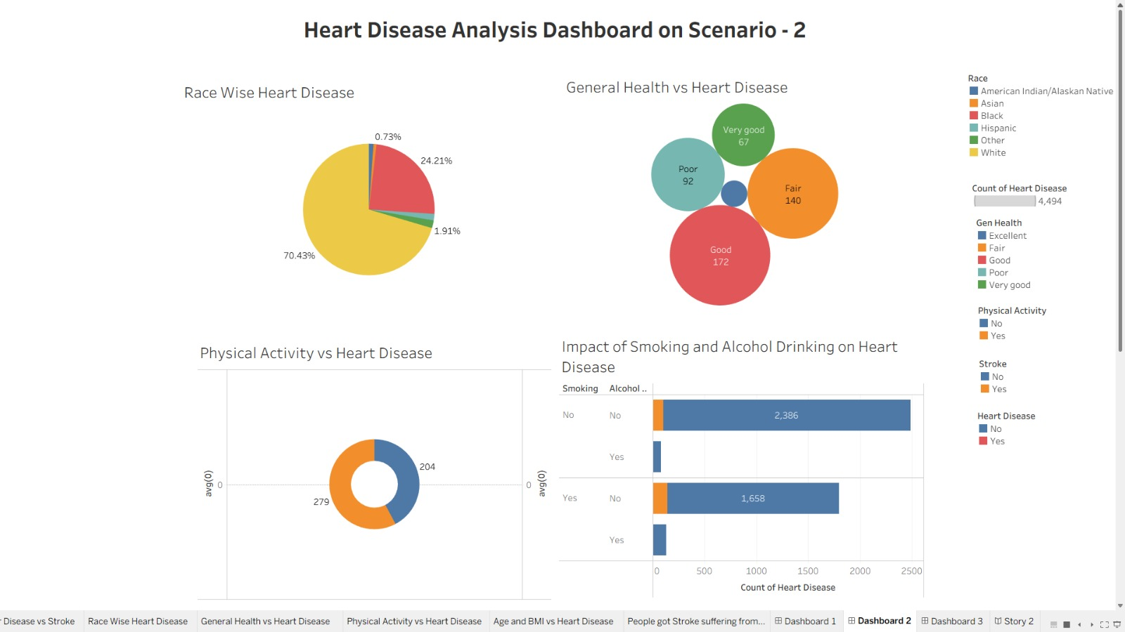
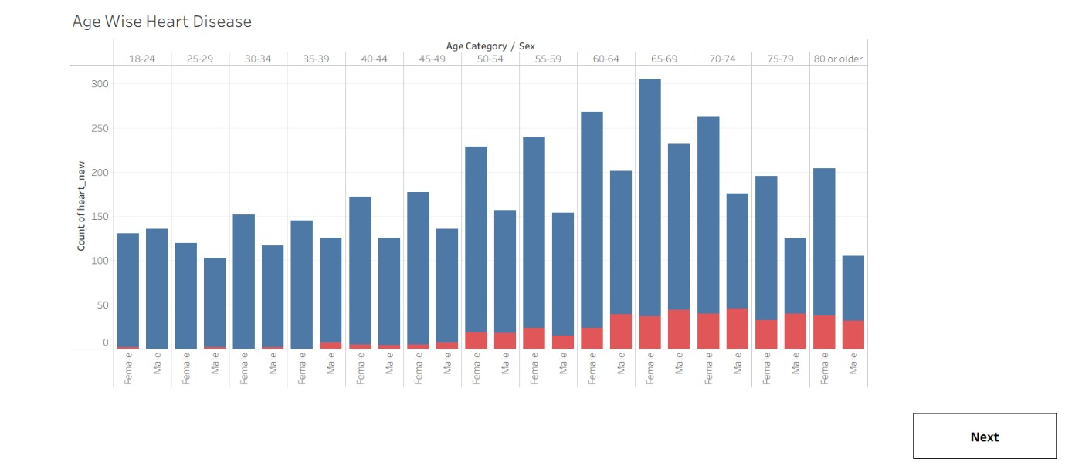

DASHBOARD 3 – INDIVIDUAL / USER PERSPECTIVE
The third dashboard was developed from the perspective of individual users who want to understand their health condition and the relationship between different diseases and heart disease. This dashboard focuses on diabetes, stroke, general health, Body Mass Index (BMI), and age-related factors that influence cardiovascular health. The visualizations encourage individuals to adopt healthier lifestyles by increasing awareness of potential health risks.
The dashboard contains the following five interactive visualizations.

1. Diabetes vs Stroke
This visualization compares the relationship between diabetes and stroke among patients. It helps users understand how diabetes increases the possibility of developing stroke-related complications.

2. Other Diseases vs Stroke
This chart analyzes the relationship between stroke and other health conditions present in the dataset. It provides an overview of additional medical factors that may contribute to stroke risk.

3. General Health vs Heart Disease
This visualization compares different levels of general health with the occurrence of heart disease. It shows that individuals with poor general health have a higher probability of suffering from heart disease.

4. Age and BMI vs Heart Disease
This chart combines Age Category and Body Mass Index (BMI) to study their impact on heart disease. It demonstrates that increasing age and higher BMI are important factors associated with cardiovascular diseases.

5. People Who Got Stroke Suffering from Diabetes and Heart Disease
This visualization identifies individuals who have experienced stroke while also suffering from diabetes and heart disease. It highlights the relationship between multiple chronic diseases and emphasizes the importance of early diagnosis and proper healthcare management.
Overall, Dashboard 3 helps individuals better understand the relationship between lifestyle habits, chronic diseases, and heart disease. The insights obtained from this dashboard can encourage people to monitor their health regularly and adopt preventive measures to reduce future health risks.
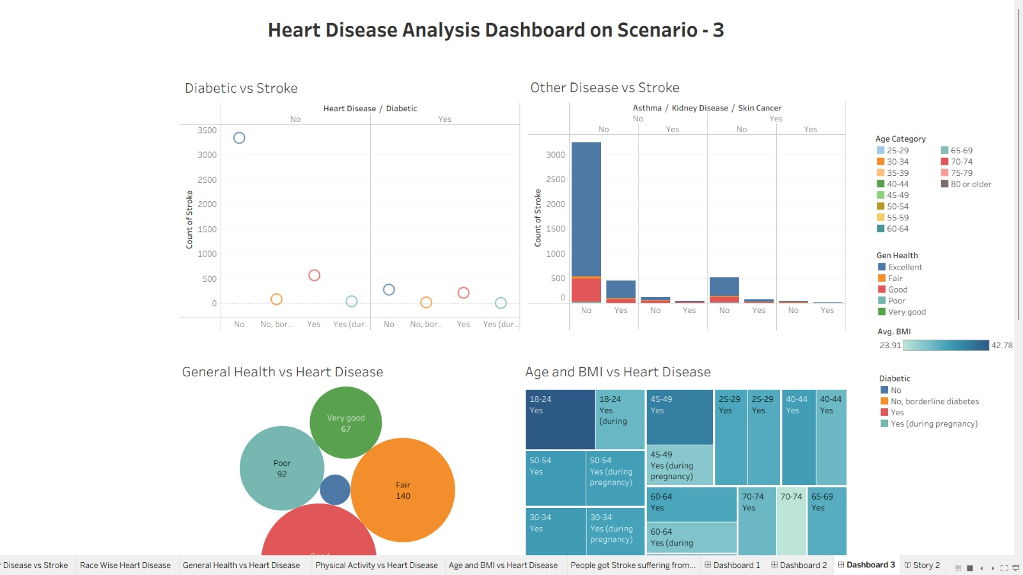
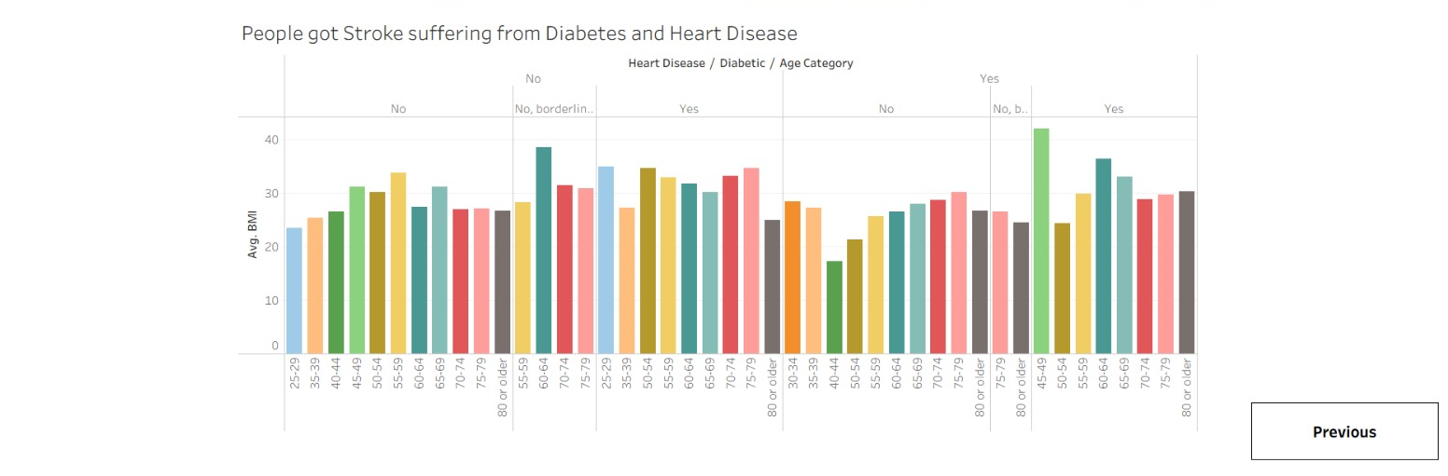

TABLEAU STORY
A Tableau Story is a sequence of dashboards and worksheets arranged to present data analysis in a logical and meaningful order. Instead of viewing individual dashboards separately, the story combines all visualizations into a single presentation that helps users understand the complete analysis step by step.
In this project, a Tableau Story was created after developing the three dashboards. Each dashboard represents a different scenario and contributes to the overall understanding of heart disease. The story begins with the analysis from the Doctor's Perspective, where the focus is on identifying high-risk patients based on age, gender, BMI, smoking, alcohol consumption, and physical activity. It then moves to the Government Perspective, which highlights disease distribution among different population groups and supports healthcare planning. Finally, the story presents the Individual/User Perspective, allowing users to understand the relationship between diabetes, stroke, general health, and heart disease.
The Tableau Story provides a structured flow of information, enabling users to interpret the analysis more effectively. Navigation buttons allow viewers to move from one dashboard to another without losing the context of the analysis. This feature improves the overall user experience and makes the presentation more interactive.
The story also helps communicate the findings in a simple and organized manner, making it suitable for healthcare professionals, government authorities, students, and general users. By combining multiple dashboards into a single presentation, the Tableau Story enhances the effectiveness of data visualization and supports better understanding of the project outcomes.
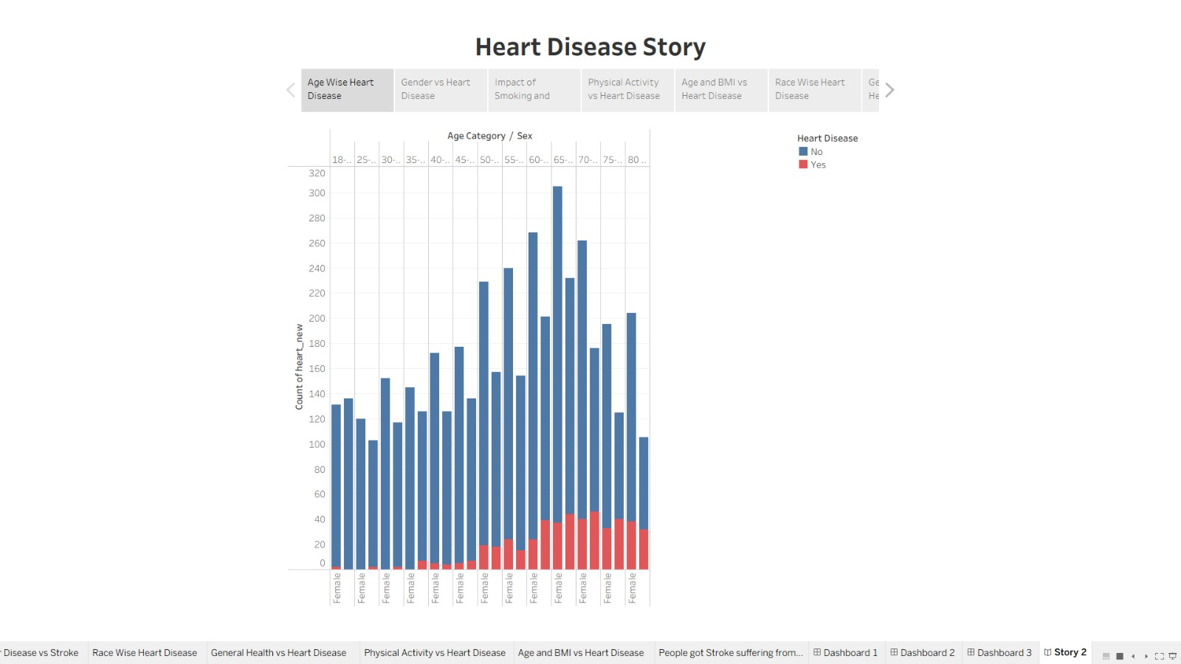

PERFORMANCE TESTING
Performance testing was conducted to ensure that the dashboards developed in Tableau Public functioned efficiently and provided a smooth user experience. The purpose of testing was to verify that the data was displayed correctly, filters responded properly, and the dashboards loaded without errors.
The first stage of testing involved validating the dataset stored in MySQL Workbench. The number of records, column names, and data types were verified to ensure that the imported data was accurate and complete. SQL queries were executed to confirm that the dataset matched the original CSV file downloaded from the SkillWallet Dashboard.
After connecting the data with Tableau, all charts, graphs, and filters were tested individually. Interactive filters such as age category, gender, race, and health indicators were applied to verify that the dashboards updated correctly. Each visualization displayed accurate information without affecting the performance of other charts.
The Tableau Story was also tested to ensure smooth navigation between dashboards. Finally, the published dashboards were accessed through the Tableau Public link to verify successful web integration and online accessibility.
The performance testing confirmed that the dashboards were functioning correctly, the visualizations responded efficiently, and the published project was ready for demonstration and public access.

Performance Testing Summary
Testing Parameter | Status
Dataset Imported Successfully | Passed
Duplicate Records Removed | Passed
MySQL Database Verified | Passed
Tableau Connection Successful | Passed
Dashboard Filters Working | Passed
Story Navigation Working | Passed
Tableau Public Publishing | Passed
Web Integration Successful | Passed




PUBLISHING ON TABLEAU PUBLIC
After completing the dashboards and Tableau Story, the final workbook was published on Tableau Public to make the project accessible online. Tableau Public is a cloud-based platform that allows users to publish, share, and access interactive dashboards through a web browser.
Before publishing, all dashboards, worksheets, and stories were reviewed to ensure that the visualizations were accurate and functioning correctly. Interactive filters, charts, and navigation options were tested to verify that they responded properly without errors.
The publishing process was completed by signing in to a Tableau Public account and selecting the Save to Tableau Public option from Tableau Desktop. After uploading the workbook, Tableau automatically generated a public URL that allows users to access the dashboards from any device with an internet connection.
Publishing the project on Tableau Public offers several advantages. It enables easy sharing of dashboards with project evaluators, faculty members, and other users without requiring Tableau Desktop software. It also supports online accessibility, interactive visualization, and public demonstration of the completed project.
The successful publication of the Heart Disease Analysis project marked the completion of the visualization phase and prepared the dashboards for web integration and online presentation.

Published Tableau Public Link
https://public.tableau.com/app/profile/devang.agrawal5827
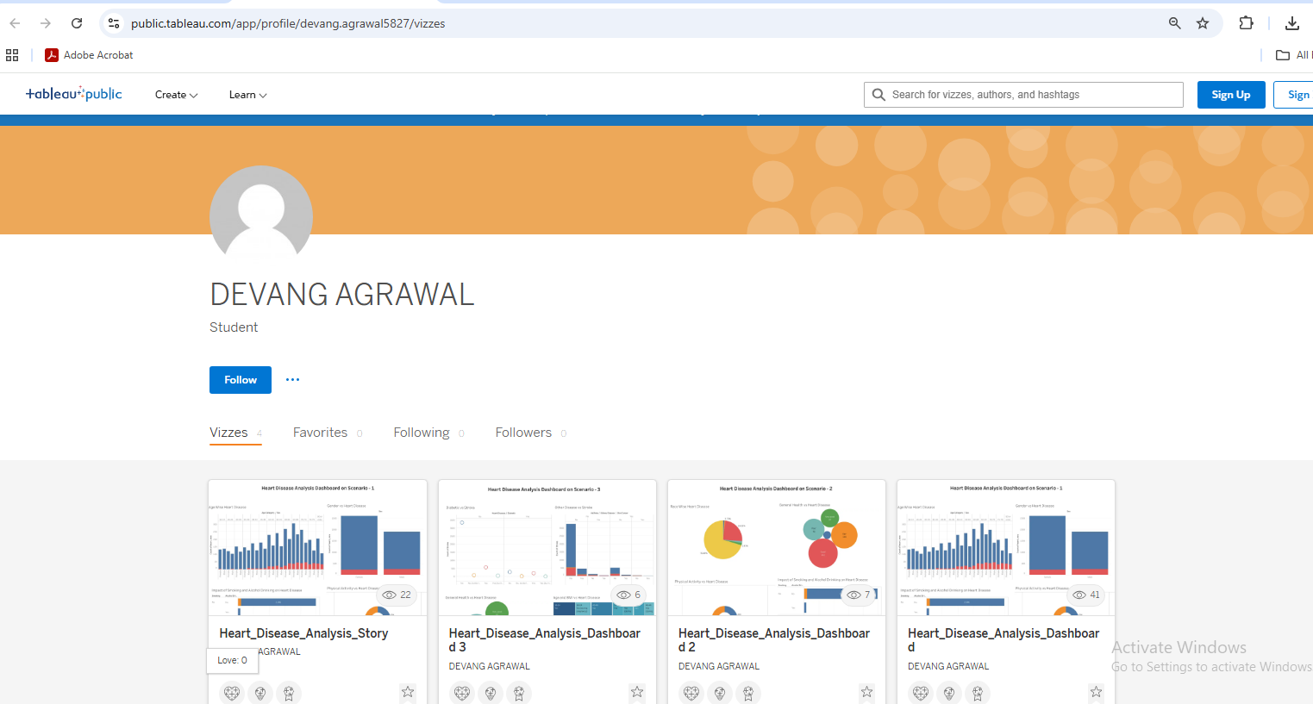

WEB INTEGRATION
The final stage of the project involved integrating the published Tableau dashboard into a web page. Web integration allows users to access the interactive dashboard directly through a website without opening Tableau Desktop. This improves accessibility and enables users to explore the visualizations from any device connected to the internet.
After publishing the dashboard on Tableau Public, the Embed Code provided by Tableau Public was copied and inserted into an HTML web page using an iframe. This allowed the dashboard to be displayed directly inside the webpage while maintaining all interactive features such as filters, charts, tooltips, and navigation.
The web page was developed using basic HTML and opened in a web browser to verify that the embedded dashboard loaded correctly. The dashboard responded successfully to user interactions, including filter selection and chart updates, confirming that the integration was successful.
Web integration provides several benefits, including easy online access, improved user experience, and the ability to share the project with faculty members, evaluators, and other users through a single web link. It also demonstrates the practical implementation of Business Intelligence solutions in a web environment.
The successful completion of web integration ensured that the Heart Disease Analysis project could be accessed and demonstrated conveniently without requiring additional software installation.

Technologies Used
- HTML
- Tableau Public
- Web Browser
- Embedded iFrame
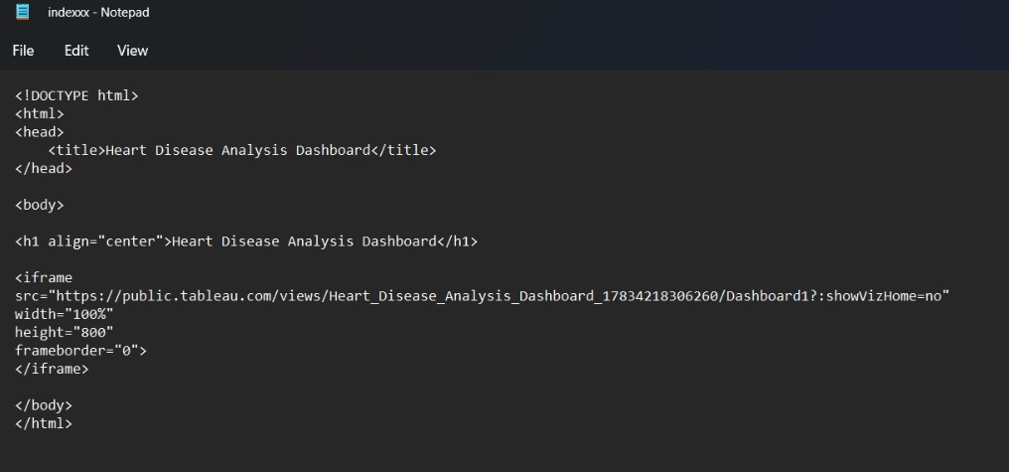
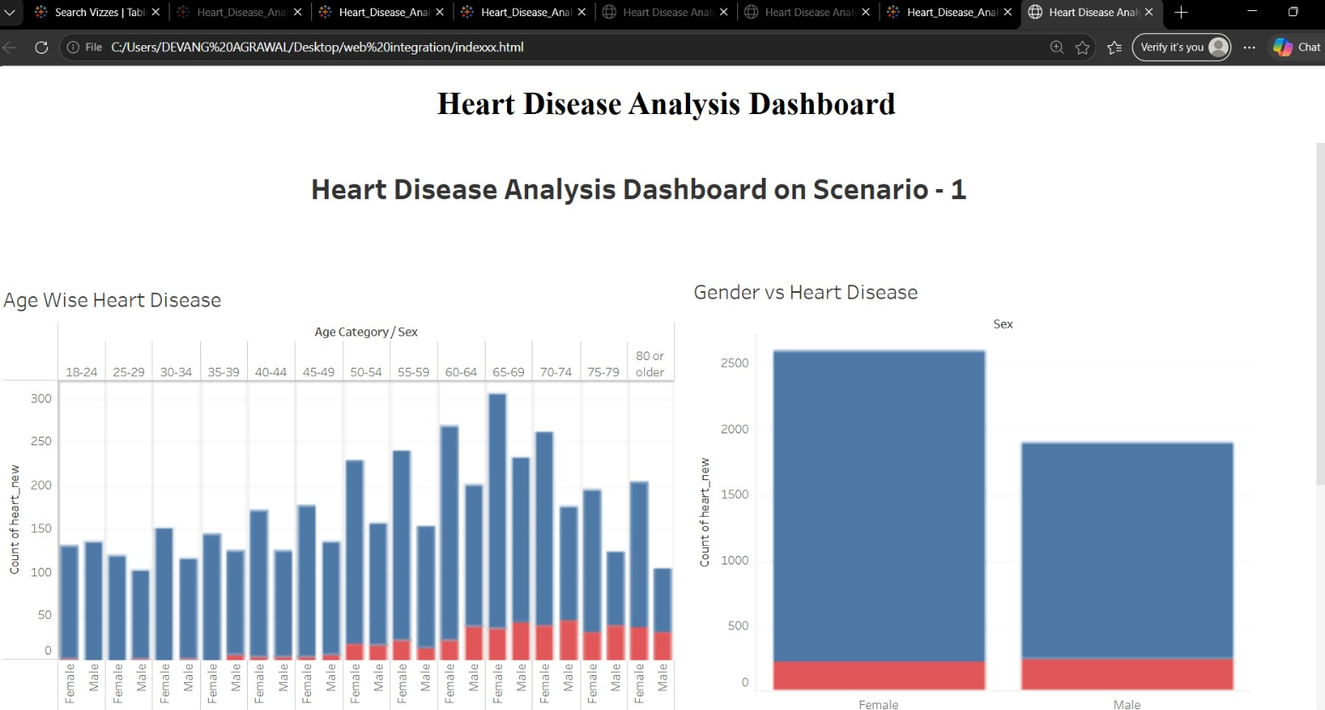

RESULTS AND FINDINGS
The Heart Disease Analysis project was successfully completed using MySQL Workbench and Tableau Public. The collected dataset was cleaned, organized, stored in a database, and transformed into interactive dashboards that provide meaningful insights into the factors associated with heart disease. The analysis helped identify important relationships between demographic characteristics, lifestyle habits, and medical conditions.
The first dashboard revealed that the occurrence of heart disease increases with age and is comparatively higher among male patients. It also highlighted the significant impact of smoking, alcohol consumption, higher Body Mass Index (BMI), and lack of physical activity on the risk of developing heart disease.
The second dashboard provided insights from a public health perspective. It showed variations in heart disease among different racial groups and demonstrated that individuals with poor general health are more likely to suffer from cardiovascular diseases. The dashboard also emphasized the importance of physical activity and healthy lifestyle habits in reducing disease risk.
The third dashboard focused on the relationship between diabetes, stroke, and heart disease. The analysis indicated that individuals suffering from diabetes and poor general health have a greater likelihood of developing heart disease and stroke. It also showed that increasing age and higher BMI contribute significantly to cardiovascular health risks.
The Tableau Story successfully combined all three dashboards into a logical sequence, making the analysis easier to understand. Performance testing confirmed that all filters, charts, and dashboards functioned correctly, and the project was successfully published on Tableau Public and integrated into a web page.

Major Findings
- Heart disease cases increase with age.
- Male patients showed a higher occurrence of heart disease.
- Smoking and alcohol consumption are important lifestyle risk factors.
- Physical activity is associated with a lower risk of heart disease.
- Poor general health increases the likelihood of cardiovascular disease.
- Diabetes and stroke are strongly related to heart disease.
- Tableau dashboards improved data interpretation through interactive visualization.
Overall, the project successfully achieved its objective of converting healthcare data into meaningful visual insights that support better understanding and decision-making.

CONCLUSION
The Heart Disease Analysis Using Tableau project was successfully completed as part of the NASSCOM Data Analytics Internship. The project provided practical experience in data collection, data cleaning, database management, SQL operations, data visualization, and web integration using modern Business Intelligence tools.
The Heart Disease dataset was collected from the SkillWallet Dashboard, cleaned by removing duplicate and redundant records, and stored in MySQL Workbench. SQL queries were used to verify and organize the dataset before connecting it with Tableau Public. Three interactive dashboards and a Tableau Story were developed to analyze different aspects of heart disease from the perspectives of healthcare professionals, government authorities, and individual users.
The dashboards clearly demonstrated the relationship between age, gender, Body Mass Index (BMI), smoking, alcohol consumption, physical activity, diabetes, stroke, and general health with the occurrence of heart disease. The visualizations made complex healthcare data easy to understand and provided meaningful insights that can support preventive healthcare and informed decision-making.
The project also demonstrated the importance of data visualization in presenting healthcare information effectively. Publishing the dashboards on Tableau Public and integrating them into a web page improved accessibility and allowed the project to be shared easily with evaluators and other users.
Overall, this project successfully achieved its objectives and enhanced practical knowledge of Data Analytics, MySQL Workbench, and Tableau Public. It also strengthened problem-solving, analytical thinking, and data visualization skills, which are valuable for future academic projects and professional careers in the field of data analytics.

FUTURE SCOPE
The Heart Disease Analysis project provides a strong foundation for healthcare data visualization and analysis. Although the project successfully demonstrates the use of MySQL Workbench and Tableau Public for analyzing heart disease data, several improvements can be made in the future to enhance its functionality, accuracy, and practical applications.
One possible enhancement is the integration of Machine Learning algorithms to predict the likelihood of heart disease based on patient health records. Predictive models can assist healthcare professionals in identifying high-risk patients at an early stage and support timely medical intervention.
The project can also be extended by connecting it with real-time healthcare databases instead of using a static dataset. This would enable hospitals and healthcare organizations to monitor patient information continuously and make data-driven decisions based on the latest available data.
Another improvement would be the development of a web-based or mobile healthcare dashboard that allows doctors and patients to access health reports from anywhere. Such a system could provide personalized health recommendations and improve patient awareness regarding heart disease prevention.
Additional healthcare parameters such as blood pressure, cholesterol levels, ECG reports, medication history, family medical history, and laboratory test results can also be incorporated into the analysis. Including more medical attributes would improve the accuracy and depth of the visualizations.
Future versions of the project may also include automated report generation, advanced filtering options, geographical analysis, and integration with cloud-based database systems. These enhancements would increase the usefulness of the project for hospitals, healthcare researchers, government organizations, and public health agencies.
In conclusion, the project has significant potential for future development and can be expanded into a comprehensive healthcare analytics system capable of supporting clinical decision-making and improving healthcare services.

REFERENCES
The following references were consulted during the development of the Heart Disease Analysis Using Tableau project.
- Tableau Public. Official Tableau Public Documentation. Available at: https://public.tableau.com/
- Tableau Software. Tableau Desktop Help and User Guide. Available at: https://help.tableau.com/
- MySQL. MySQL Workbench Documentation. Available at: https://dev.mysql.com/doc/
- Oracle Corporation. MySQL Official Website. Available at: https://www.mysql.com/
- NASSCOM FutureSkills Prime. Data Analytics Learning Resources and Internship Platform.
- SkillWallet Dashboard. Heart Disease Dataset provided during the NASSCOM Data Analytics Internship.
- Centers for Disease Control and Prevention (CDC). Heart Disease Facts. Available at: https://www.cdc.gov/heart-disease/
- Microsoft. SQL Documentation and Database Concepts. Available at: https://learn.microsoft.com/sql/
- Various lecture notes, online tutorials, and educational resources related to Data Analytics, SQL, MySQL Workbench, and Tableau Public were referred to for academic learning purposes.

